# Fee

The fee module allows the users to collect and maintain the fee collection details of the student. This module eases the fee collection such as college fees, transport fees, hostel fees, mess fees, exam fees, admission fees, etc., and accurate reports can be generated based on the requirements.

It helps you allot a fee discount for some students who are not able to pay the full amount. Once the fee is collected from the students, the receipt will be generated and issued to the students.

## Purpose

The purpose of this document is to describe software functional and nonfunctional requirements for the release of 2.0 of the Higrade+ – Fee module. This document is intended to be used by the project team members who will implement and verify the correct functioning of the system.

## Scope and Feature

The scope of this module is to maintain the student’s fee collection details, which is collected by the college.

* Maintain Fee Structure
* Maintain Fee Collection details
* Generate Receipt

## Definitions & Acronyms

| **HG** | HiGrade |
| --- | --- |
|  |  |

# Background

## Problem Statement

| **The problem of** | Collecting different types fees (College Fee, Bus Fee, Exam fee, etc.) from the students. |
| --- | --- |
| **Affects** | Management, Fee Admin, Accountant & Students |
| **The impact of which is** | Difficult to track the fee collection details. |
| **A successful solution would be** | Fee module in Higrade+ |

## Stakeholders

## User Class and Characteristics

| **Fee Admin** | A registered user who can define the fee settings and maintain Student Fee Record, Account wise Fee Record, Fee Structure, Remittance, Receipt Log, Fee Ledger, Bank Reconciliation Statement, Student Concession, Receipt Log Changes. |
| --- | --- |
| **Accountant** | A registered user who can collect the fee from the student |

# System Architecture

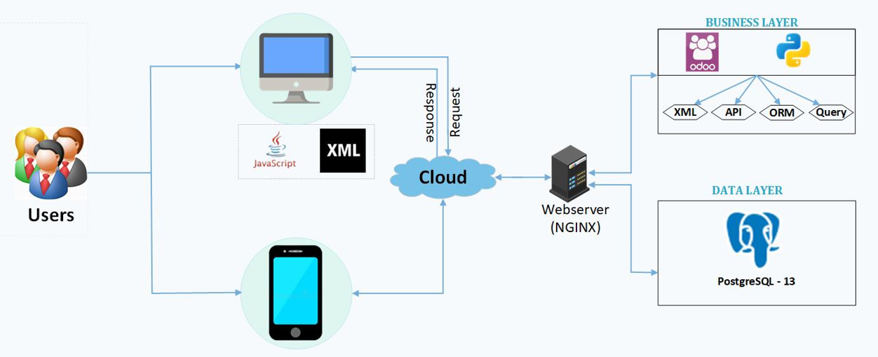

**Figure 1: System Architecture of HG**

# Overview

Logged in users can perform the following actions with respect to their user rights.

1. Configure Fee Settings
2. Collect the Fee
3. Generate Fee Receipt
4. Allocate / Remove Fee Concession
5. Generate Reports

## Process Flow Diagram

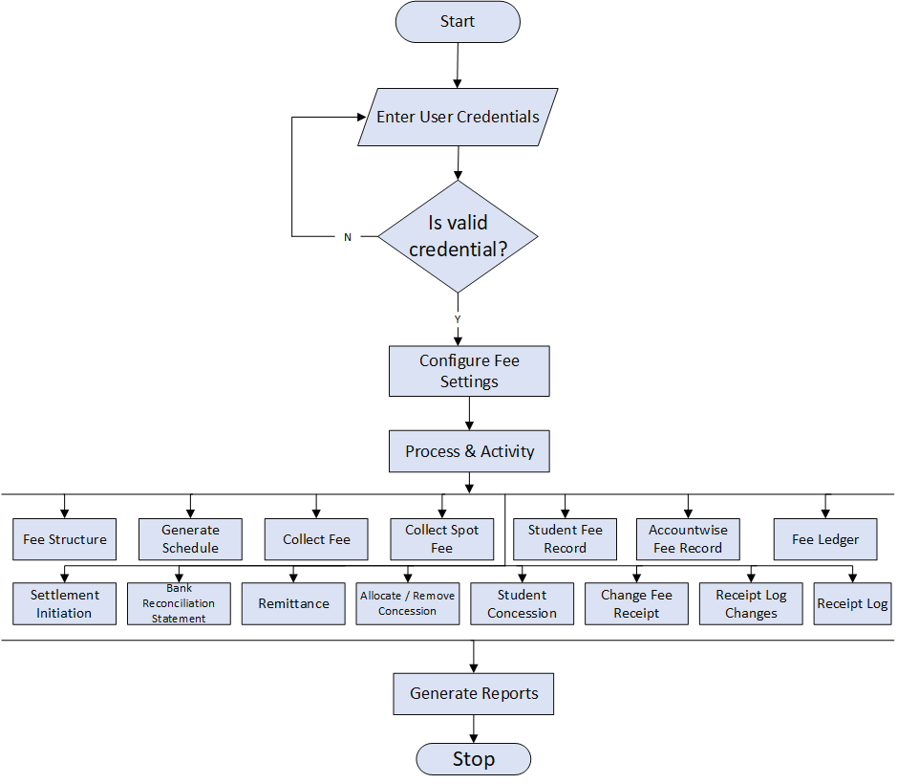

**Figure 2: HG Fee Process Flow Diagram**

# Feature

## Process Flow Diagram

| **Description** | **Priority** |
| --- | --- |
| ***Dashboard*** | |
| Provision to have a dashboard. | L |
| ***Configuration*** | |
| Provision to define Bank Account details | H |
| Provision to define Fee Category details | H |
| Provision to define Fee Head details | H |
| Provision to define Fee Group details | H |
| Provision to define Fee Collection Cycle details | H |
| Provision to define Fee Concession details | H |
| Provision to define Boarding Point Fee details | H |
| Provision to define Fee Receipt settings | H |
| Provision to define No Due Certificate Setting | H |
| ***Activity*** | |
| Provision to Collect Fee from the students | H |
| Provision to Collect Spot Fee from the students | H |
| Provision to Initiate Settlement | H |
| Provision to Generate a Schedule for the approved Fee Structure | H |
| Provision to Allocate Boarding Fee | H |
| Provision to Allocate / Remove Concessions for the students | H |
| Provision to Generate Vouchers | H |
| Provision to Change Fee Receipt | H |
| ***Process*** | |
| Provision to view Student Fee Record | H |
| Provision to View/Import Accountwise Fee Record | H |
| Provision to create Fee Structure | H |
| Provision to view Remittance | H |
| Provision to Receipt Log | H |
| Provision to view Fee Ledger | H |
| Provision to view Bank Reconciliation Statement | H |
| Provision to view Student Concession | H |
| Provision to view Receipt Log Changes | H |
| ***Report*** | |
| Provision to generate Daily Fee Collection | H |
| Provision to generate Spot Fee Collection | H |
| Provision to generate Monthly Fee Collection | H |
| Provision to generate Fee Concession | H |
| Provision to generate Fee Due Register | H |
| Provision to generate Fee Ledger | H |
| Provision to generate Transport Fee Details | H |
| Provision to generate Bonafide (Fee) | H |

## Non-Functional Requirements

| **Category** | **Subcategory** |
| --- | --- |
| Usability | *Accessibility*  This application can be accessible through Firefox. |
| Reliability | *Availability*  The system would be available 24X7. |
| *Robustness*  For every invalid input from the user, the system displays a meaningful error message explaining in what format the input is to be fed into the system. |
| *Accuracy*  System shall provide high precision for any resolution and data accuracy that is required in the system’s output. |
| *Fault Tolerance*  Bug-free system shall be available. |
| *Safety*  Information maintained in the system is kept confidential, especially the user details. |
| *Security*  Confidential information like user details are stored in Encrypted format using Simple Encrypt algorithm |
|  | *Correctness*  All the possible exceptions are captured and logged while executing the process. |
| Performance | *Throughput*  Average system throughput should be minimum 2 packets / second. |
| *Response Time*  Average system response time should be less than five seconds. |
| *Recovery Time*  Average recovery time should be less than 24 hours. |
|  | *Startup/Shutdown Time*  The system shall be operational within 1 second from complete application server start-up. |
| *Capacity*  Generally the system shall accommodate any number of concurrent users. |
| *Utilization of Resources*  CPU utilization shall not exceed 25% when the application is functioning. |
| Supportability | *Adaptability*  Deployment time on a new version of ATS shall be no longer than one day. |
| *Maintainability*  An error log containing information about all critical errors shall be traced every day. |
| *Compatibility*  Nil |
| *Configurability*  N/A |
| *Upgradeability* |
| *Installability* |
| *Scalability*  Generally, the system shall accommodate 100 concurrent users. |
| *Portability*  Changing the operating system in the future shall not require rewriting application logic. |

# Operating Environment

## Hardware Requirements

This section shall identify the hardware requirements for Higrade+. The complete configuration details are listed below:

* Processor :
* Memory :
* RAM :

## Software Requirements

This section shall identify the software platform requirements. All details listed below shall be documented:

* Front End     :
* Back End     :
* OPERATING SYSTEM :
* BROWSER     :

# Data Dictionary

# 

# Licensing Requirements

# 

# Legal, Copyright, and Other Notices